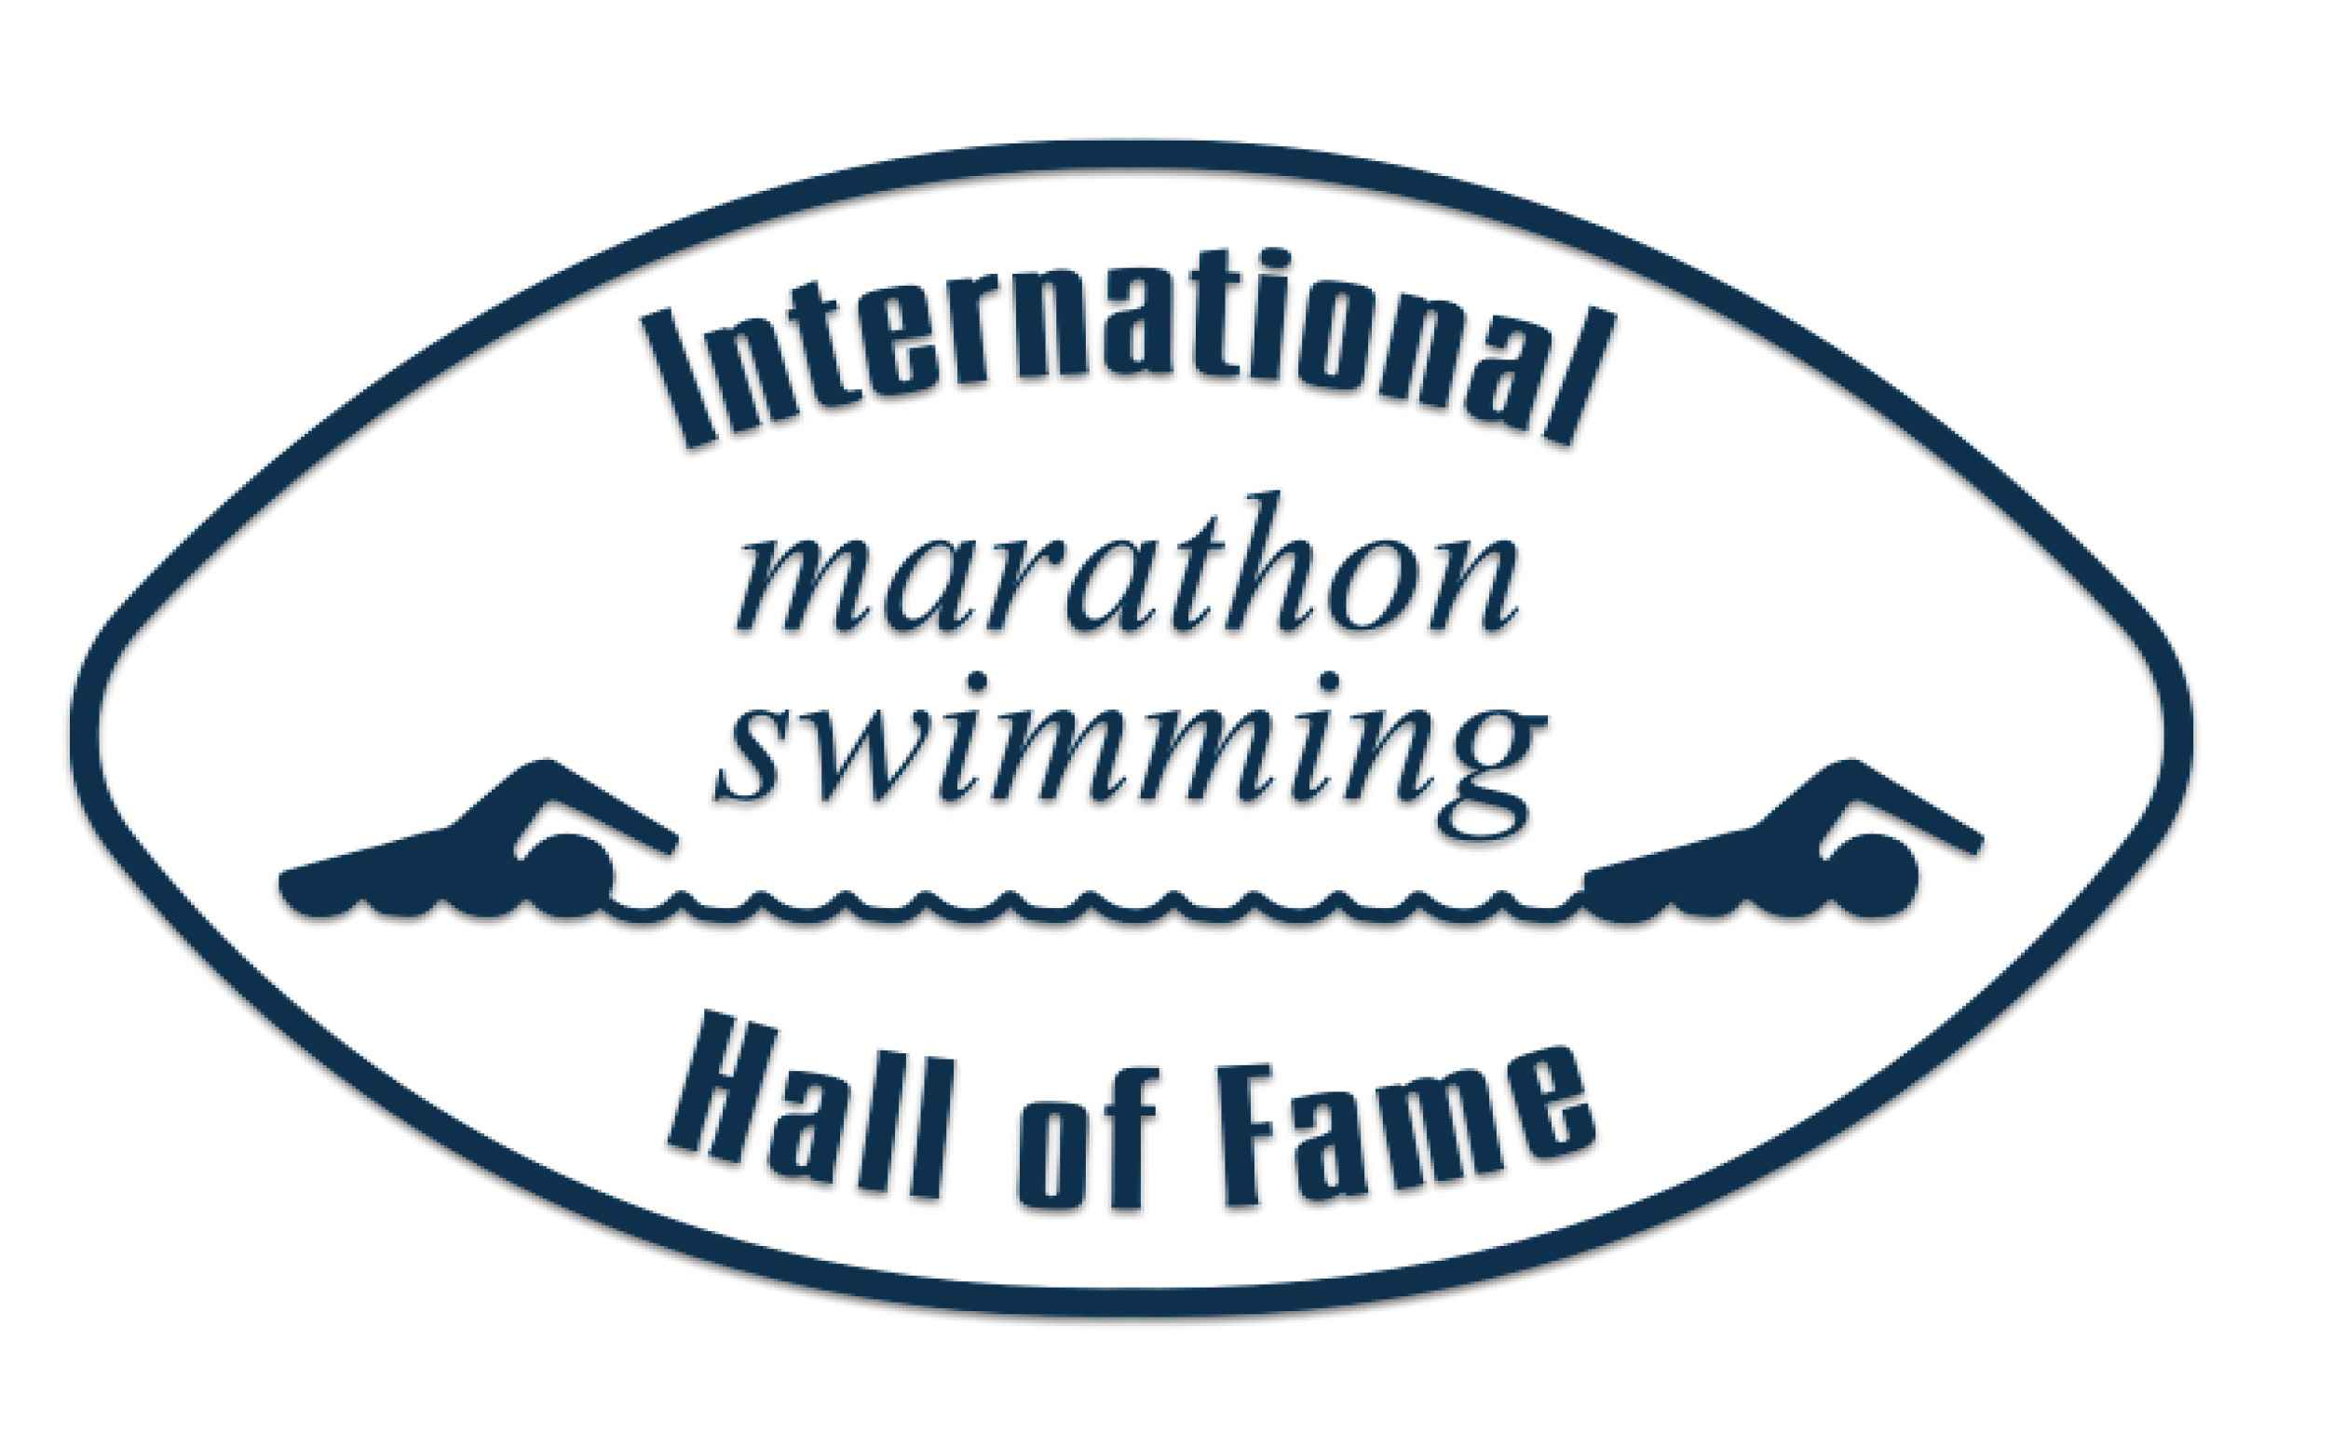

Criteria for Selection of Poseidon Award
The Poseidon Award recognizes outstanding contributions to marathon swimming. This award honors individuals or organizations that have significantly advanced the sport of Marathon swimming through their personal efforts or initiatives. The winner is decided by the IMSHOF Selectors. Only individual IMSHOF Inductees are now eligible to receive this award, a decision established by IMSHOF in 2021.
It is important to realize that there is no set formula to determine this award. The ultimate decision is made by the IMSHOF Selection Committee. This committee is made up of more than 70 selectors ranging in age from 20s to 90s and almost all are IMSHOF Honorees (see https://www.imshof.org/nominate-selectors) representing a globally diverse cross-section of the international marathon swimming community. They come from different eras and roles within the sport representing swimmers, contributors, and combinations of both.
Even the most outstanding application will benefit from a well-written nomination. It is advisable (and quite common) to ask for a peer review from a member of the Executive Committee (imshofvoting@gmail.com). Several drafts are often exchanged/discussed before final submission. Your request will be passed on to members of our community who can provide objective feedback. IMSHOF can also assist in translating from certain languages.
Selection will generally require a swimming and/or contributor career of more than 10 years.
Lobbying for selection is not tolerated. The IMSHOF Executive Committee reserves the right to remove a nomination in these cases.
The nomination should be a maximum of two pages and focus on the most compelling aspects of the nominee’s swimming and/or contributions to open water swimming. Accuracy and truthfulness are paramount. The selection committee completes a light fact check but if the facts are incorrect, expect every selector who notices to simply stop reading (and probably ignore this nomination in the future). IMSHOF suggests you ensure that resources such as longswim.com list and openwaterpedia.com are complete (as possible) and accurate BEFORE you start completing the form below. If a potentially significant question is raised during the voting process, any votes will be considered when all the questions have been answered.
The nomination process is private. A nomination is NOT an honor so please do not publicize your nomination in ANY way. IMSHOF publishes an annual list of Inductees and award winners on Facebook (@IMSHOF), Instagram (@imshofame), http://www.imshof.org/ and our newsletter. All nominees and nominators will automatically be added to the newsletter subscription list.

The sport contains three types of marathon swims.
​Solo swims in straits, channels, rivers, lakes, and oceans – examples: the English Channel, Derwent River, Foveaux Strait. This would also include solo swims completed in tandem formation (together) example: a tandem in Catalina, 4 solo swimmers together in Gibraltar, etc.
Races in World Aquatics (previously FINA)/Majors: Competitive participation in the Olympic Games, World Championships, and 10K Marathon Swim Cup Events. See Majors/Swims | IMSHOF.
Other races: LEN, national championships, Rottnest, World University Games, Lake Zurich, S.C.A.R., etc.
​Solo swims in straits, channels, rivers, lakes, and oceans – examples: the English Channel, Derwent River, Foveaux Strait. This would also include solo swims completed in tandem formation (together) example: a tandem in Catalina, 4 solo swimmers together in Gibraltar, etc.
While the word “epic” is missing, it plays a critical part. Swimming 33 km all the way to France or 33 km all the way around an island has a better ring than halfway across (33 km) a body of water. Claims to have “swum the English Channel in an outdoor pool (680 laps of 50 meters each)” or “in Dover Harbor (33 times between the walls which are 0.5 km apart)”, despite being 33 km, are not acceptable nomination inclusions. IMSHOF nominations cannot include swims done outside of established marathon ratification bodies active in those waters (example Catalina Channel Swimming Federation). If multiple swimmers are in the water (and not swimming together) then it is a race (see below).
The selectors are looking for a nominee (where swimming is a major component) to have a range of swims: fresh and salt water, famous, new, 10 km, 25 km+, international, and in different temperatures. Completing a local marathon swim 25 times will have less weight than 10 marathons in 10 different countries. Speed is generally not a deciding factor for the selectors reviewing swimmer’s solo swimming biography, – however holding speed records for famous swims like the English or Catalina Channel will benefit the nomination.
Where swims are 2-way, 3-way (etc.) or stage swims – please note time for each leg of the swim, time between legs (or start dates on a stage swim) and/or overall time.
Very long swims are always impressive, but the selectors are looking for a full range, not just two very long swims.
Races in World Aquatics (previously FINA)/Majors: Competitive participation in the Olympic Games, World Championships, and 10K Marathon Swim Cup Events.
Primary consideration will be given to those nominees (where swimming is a major component) winning or having medal performances. They should have a successful history of international race events. Please note where they won a “Major”. See these links for descriptions/examples:
The Majors - Description | IMSHOF
The Majors - Winners | IMSHOF
Selection is based on the number of races, range of years, different distance, international activity, percentages of podium finishes (medals), and records.
Other races: LEN, national championships, Rottnest, World University Games, Lake Zurich, S.C.A.R., etc.
Advice to nominators for all races:
1. Longer Races: Make sure to note any 25 km + races if they are part of the swimmer’s nomination.
2. Higher place finishes against IMSHOF Honorees and/or other major winners will contribute to more impressive nominations.
3. Career Length: List at least one early and most current result – to show career length: so, a 10 km National Championship in 2001 and 36 km Capri Naples in 2022.
4. List best wins/podium positions and/or women beating men.
5. Show a range of countries, salt & fresh/cold & warm waters, and distances of races.
Although nominations of some nominees will include successes in each of the three types of marathon swims above, it is not mandatory.
IMSHOF Swimwear and Aids Criteria:
To be considered for elevation to Honoree in the IMSHOF, the nominee must have complied with the swimwear rules of the body in control of each event listed in the nomination.
In an organized competition conducted under the auspices of a recognized international or national body, the swimmer must comply with both the relevant swimwear requirements and other performance regulations as required under that body’s rules.
In some World Aquatics (previously FINA) races the swimmers are compelled to wear wetsuits in lower temperatures and are allowed to wear compression suits (which aid speed) in most events. These should be explicitly noted on the nomination.
For solo swims conducted under the auspices of the body governing that event, the nominee must comply with both the relevant swimwear requirements and other performance regulations as required under that body’s rules.
“I snuck out one night with my brother in a boat and swam the English Channel” is not an acceptable example of a swim to include on a nomination. IMSHOF honors many of the organizations which set and enforce rules and accredit swims. IMSHOF acknowledges that the growing popularity makes getting into these famous swims harder and more expensive – but the value of the organizations is too high to ever undercut.
For swims performed outside of known organizations, (under the support of private, professional, or cause-related groups,) nominees may be asked to provide evidence of the swim through creditable observers with clear details of costume or any other practices out of the norm of solo swims. IMSHOF does not accredit swims and will not include disputed swims on any nomination.

Nomination for Poseidon Award Month/Year (when submitted):
Please read the Criteria for Selection of Honorees before completing the nomination form. The nomination form is to be submitted in Microsoft Word (Calibri 11-point font) format – simply add/reduce table rows as required and replace/delete all the text in blue. A separate PDF version is also required to maintain the integrity of the nomination. Distances should be listed in kilometers (km).
The nomination is to be no longer than two pages. (These informational pages are not included as part of the two pages.) Please do not attach hyperlinks or include pictures or endorsements from others. The font color may only be in black ink. The nomination is to be emailed to mailto:imshofvoting@gmail.com no later than the submission date that can be found at https://www.imshof.org/nominate-process.
Nominees Information
Name: Include any titles Dr, PhD, MBE, Captain, and well-known nicknames (example: Sir William "Billy" Butlin). Please include all appropriate accent marks in the name. If one’s name has changed (often through marriage), then it is optional to include it (example: Sandra Bucha Kerscher). The name will be alphabetized under which name the nominee competed). The individual can also opt for the following: First Name, then married Last Name, then née Maiden Name, such as Karen Reeder, née Burton.
Country: Birth, country of residence, or country lived during majority of career
Email: Add email address (generally mandatory – explain exception)
Instagram: Add Instagram address (if using)
Facebook: Add Facebook page (if using)
Address: Street, number, City, State, Country, and Postcode
Phone Number: Cell/mobile phone (including international calling code)
Date of birth: example 21 November 1967 Date of death (if applicable): example 21 November 2017
Still an active administrator? Yes or No
Gender: Male, Female or Other
Second Contact
Name: Child, sibling, or friend who will be able to locate the nominee in 25 years
Relationship to nominee: Child, sibling, friend, etc. Email: Add this contact’s email address
Nominator’s Information
Nominator’s Name: Add name Nominator’s Email: Add email address
Nominee has read and understands the Criteria for Selection of Honorees: Yes / No

Nomination – Poseidon Award (2 pages only) Month/Year (when submitted):
Four Paragraph Summary:
Summarize how has the individual has significantly advanced the sport of marathon swimming through their personal efforts or initiatives. List their high-level achievements as a swimmer, as an administrator, pilot, and/or as a coach. These accomplishments will typically fall into one or more of these categories:
Marathon swimmer – solos completed, majors and other races: won, records (fastest, first ever, longest/slowest, youngest/oldest, total swims)
Contributors – administration, piloting and/or coaching
Please avoid adjectives (example: dominant) and focus on facts. Examples: first to run a marathon swim where 100 completed a 25k in the same session, more than 50 IMSHOF Honorees have participated in the event, member of the FINA decision making committee for 15 years, officiated at 3 Olympics IMSHOF, etc.
Swimming and/or Contribution Resume:
List all the countries (in alphabetical order) where successful marathon activities have taken place: Argentina, England, Italy, and USA
Special considerations: Anything that distinguished the nominee not addressed elsewhere - example: areas covered by IMSHOF formal initiatives (Black swimmers/contributors and swimmers with physical disabilities and those assisting)
Career breaks: explain breaks which might include injury, child-rearing, education, career, etc.
Solo swims in straits, channels, rivers, lakes, and oceans – examples: the English Channel, Derwent River, Foveaux Strait. This would also include solo swims completed in tandem formation (together) example: a tandem in Catalina, 4 solo swimmers together in Gibraltar, etc.
Detail any significant swims or contributions
Races in World Aquatics (previously FINA)/Majors: Competitive participation in the Olympic Games, World Championships, and 10K Marathon Swim Cup Events
Detail any significant swims or contributions
Other races: LEN, national championships, Rottnest, World University Games, Lake Zurich, S.C.A.R., etc.
Detail any significant swims or contributions
FINA/World Aquatics Committees, Referee, significant media work, involvement with other related Halls of Fame: IMSHOF, ISHOF, Vermont Open Water, Ireland Marathon, etc.
Detail any significant swims or contributions
Other Considerations:
Limit this to five lines or less. Through my swimming, I have raised $2 million and built an orphanage through donations and contributions.

*********End of Nomination – maximum of 2 pages in length with spacing and text fonts used above. IMSHOF will NOT sign off longer nominations.*********
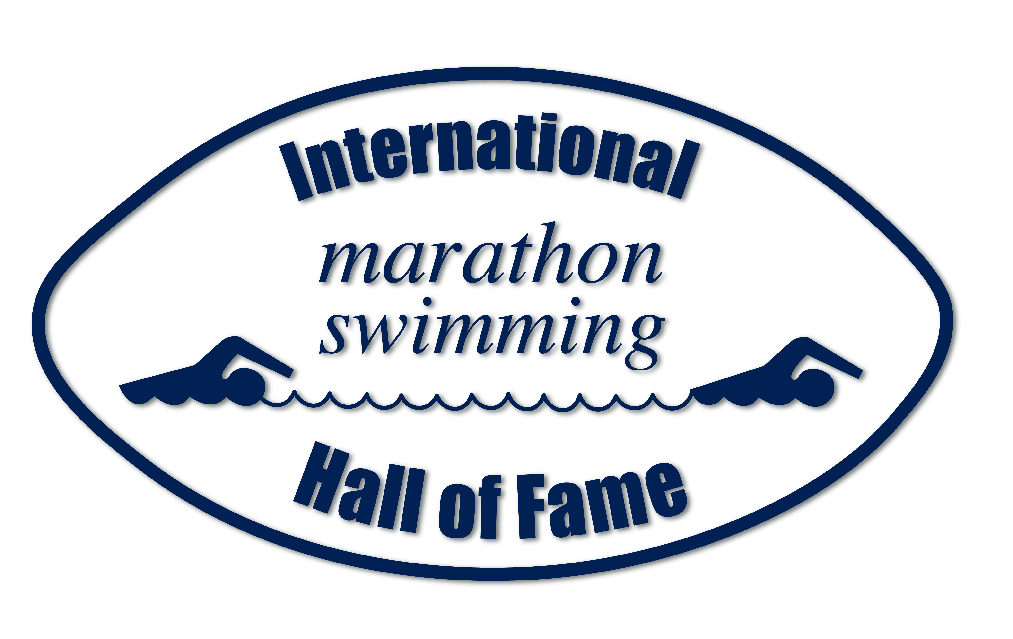

Nominee’s Agreement:
I agree with this nomination going forward for consideration and would value this award. I am following IMSHOF as a subscriber to one or more social media channels: newsletters, Facebook, Instagram, YouTube, etc. I have read and understood the criteria and selection process. I understand that I have the obligation to update IMSHOF with swims/contributions after this nomination has been submitted. If selected, I will commit to helping with my announcement, contribute requested information to the website and ceremony booklet , supply suitable pictures and video if available. I agree that some biographical and career details will be shared on ISHOF, IMSHOF and partner websites and posts – see Privacy & GDPR Policy | IMSHOF. The information above is accurate and I comply with the ethical clause below. There are no pending cases/allegations against me and will inform IMSHOF of any future cases/allegations/convictions.

Honorees will live the values associated with the International Marathon Swimming Hall of Fame including commitment, integrity, courage, respect, and excellence.

Drug Test Failure (adverse analytical findings, atypical findings, and other assorted anti-doping rule violations) by WADA or an authorized WADA body in any aquatics sport, prevents a nominee from being selected and results in the removal of an honoree from the IMSHOF. This does not apply if the finding is overturned on appeal (reduction or removal of any punishment on appeal is not considered if the finding is not overturned). This can be a current test or a future test on an old sample.

Sexual Assault Conviction of a Child (and all appeals have been exhausted) by a local court prevents a nominee from being selected and results in the removal of an Honoree from the IMSHOF.

Fraud committed in an organized fashion to create false marathon records. (Example: an organization altering observer logs or selling false marathon completion certificates.) This prevents a nominee from being selected and results in the removal of an Honoree from the IMSHOF.

Safety is a top priority in the sport. Individuals or Organizations which repeatedly engage in unsafe practices do not meet our ethics criteria.

​
Encourage participation by all interested swimmers and contributors. Individuals or Organizations which repeatedly engage in creating entry barriers or a non-welcoming environment based on disability; race; country of origin; gender or gender identity/preference do not meet our ethics criteria. IMSHOF continues to monitor these criteria and evolve it accordingly over time.

The five specific ethical values described above may not be exhaustive in our global future. The IMSHOF deplores any ethical violations that seriously diminish the reputation of the IMSHOF and the sport of open water swimming. Even a charge or suspicion of such an ethical violation may cause a nomination or an announcement to be withdrawn. For inductees, IMSHOF will generally wait for a determination by the courts (and appeals exhausted) before removal is considered.

_____________________________ _____________________________ ______________
Nominee’s Name (Print) Signature Date

If the administrator is no longer living – this should be signed by the nominator – to the best of their knowledge.

The IMSHOF reserves the right to remove information for the ballot that is not relevant or swims that are not ratified.

Nominations that are not successful but receive a significant number of votes will automatically be included on the ballot only the following year. Nominations with low votes will be removed and will generally not be able to be resubmitted for two years, and then only if additional significant swims/contributions have been accomplished in the interim. All nominators and nominees will be contacted within 6 weeks of the conclusion of the voting process, with the selection outcome. IMSHOF will not enter discussions with nominators, nominees, or anyone else about unsuccessful nominations.

End

